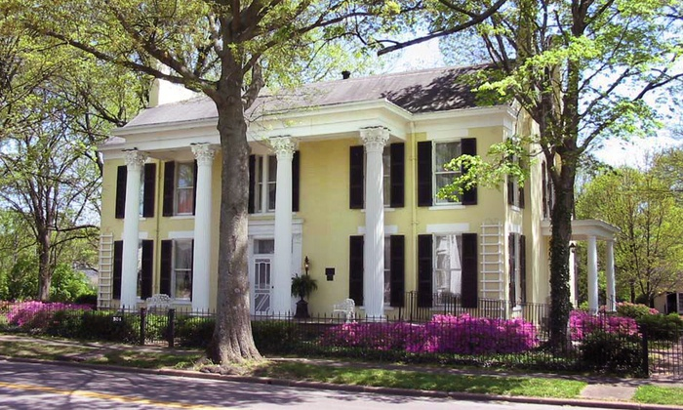

***ADSMORE HOUSE & GARDENS***

**PLANTERS BANK PASSPORT 50 PRESENTS…..**

**Join us on Thursday, July 17, 2025, for this motorcoach day trip to Princeton, KY, as we step back in time and visit *Adsmore,* a living house museum. Leave the present and enter into an era of top hats and fans, elegant china and crystal, and button shoes. *Adsmore,* meticulously restored, reflects the lifestyle of the prominent Smith-Garrett family at the close of the “Golden Age”. Prior to our visit to *Adsmore*, we will have lunch at Adams’ Breezy Hill Farm Restaurant. After touring *Adsmore* House & Gardens (And Gift Shop!), we will make a stop at Newsom’s Old Mill Store, one of a dwindling number of truly authentic country stores still in operation.**

**10:00 a.m. – Depart Park Plaza Shopping Center (across from McDonald’s on Ft. Campbell Blvd.) – South End on hill behind Car Wash**

**11:00 a.m. – Lunch at “Adams’ Breezy Hill Farm Restaurant”**

**12:30 p.m. – Tour *Adsmore* House & Gardens**

**Approx. 2:30 – 3:00 p.m. – Depart *Adsmore* for a stop at Newsom’s Old Mill Store**

**Cost is $88 per person and is all inclusive. PLEASE CALL CAROLYN COBB AT 270-890-1617 or EMAIL** [**carolyn.cobb@plantersbankonline.com**](mailto:carolyn.cobb@plantersbankonline.com) **TO MAKE A RESERVATION**. **CHECKS SHOULD BE** **MADE PAYABLE TO PLANTERS BANK.**  **HURRY….DAY TRIPS SELL OUT QUICKLY!**



**Member FDIC**