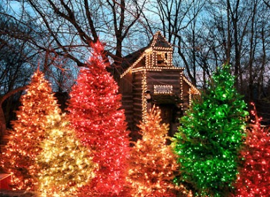

**Planters Bank Passport 50 Presents……. “*CHRISTMAS IN BRANSON”***

Join us for a motor coach “holiday getaway” to this popular group destination, Branson, MO, and kick off the holiday season **November 3-6, 2025**. Included in this package: deluxe motor coach transportation, 3 nights lodging at the Thousand Hills Resort Hotel (luggage service included), 6 meals, 5 shows:

Shows: Dublin Irish Tenors & Celtic Ladies; Clay Cooper Country Express; Dutton Family Christmas; The Haygoods; Sight & Sound Theatre Presents *DAVID*; and Christmas Wonderland. Included is time for shopping at Branson Landing and Grand Village, with lunch on your own. On the way home, we will have a lunch stop (on your own) at Lambert’s, famous for their “throwed rolls”!

Cost is: **$828 per person Double; $774 per person Triple;** **$l,034 Single.**

**Deadline for reservations is SEPTEMBER 3. A deposit of $200 per person is due** **upon reservation.** **The balance will be due by September 10.** Please contact Carolyn Cobb at 270-890-1617 or email [carolyn.cobb@plantersbankonline.com](mailto:carolyn.cobb@plantersbankonline.com) to make a reservation/deposit for this fun holiday excursion. **There is an optional cancellation protection plan available.**



Member FDIC