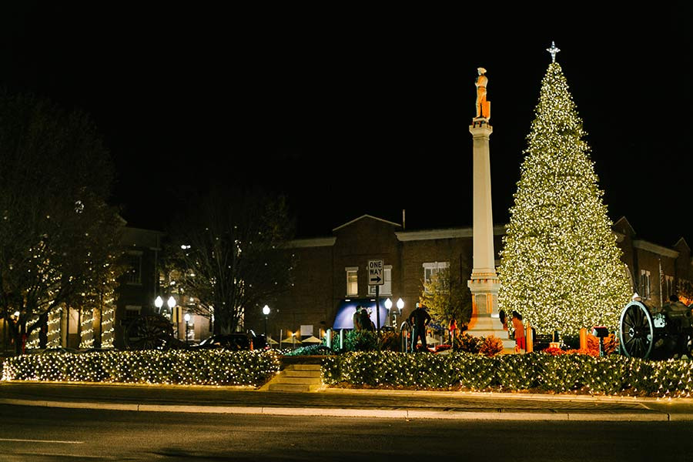
Historic Downtown - Franklin, TN
DECEMBER 1, 2026
You are invited to join PLANTERS BANK PASSPORT 50 for a holiday motor coach trip to Franklin, TN, for shopping and “lunch on your own” in the historic downtown on Tuesday, December 1, 2026. Cost for this day trip is $65 per person and due upon reservation. (Hurry…space is limited!) If you wish to make a reservation, call Carolyn Cobb at 270-890-1617 or email carolyn.cobb@plantersbankonline.com. Once you have secured your space, please make your check payable to PLANTERS BANK and mail to P.O. Box 1570, Hopkinsville, KY 42241, ATTN: Carolyn Cobb. If you prefer, you may drop your check (in an envelope, please) at any of our branch locations…just be sure my name appears on the outside of the envelope. Here is our itinerary for the day:
8:30 a.m. - Depart Park Plaza Shopping Center, 2525 Ft. Campbell Blvd., Hopkinsville (south end by Planet Fitness and on hill behind the Auto Wash), directly across from McDonald’s.
10:00 a.m. (Approximately) - Arrive Franklin, TN
Lunch Is “on your own” at any of the eateries in our location!
2:00 p.m. - Meet and board the motor coach for a visit to “The Collective Boutiques” (formerly The Painted Tree)
4:30-5:00 p.m. (Approximately) - Depart Franklin
6:30 p.m. - (Approximately) - Arrival back in Hopkinsville
Note: If you must cancel, you will be responsible for finding someone to go in your place if you want to receive a refund. If I have a “wait list”, I will assist you with finding your replacement. Please notify me as soon as possible if you must cancel. Thank you for banking and traveling with Planters Bank. HAPPY HOLIDAYS!
 Member FDIC

