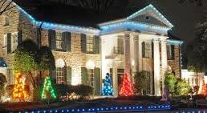
GRACELAND: An Iconic American Landmark
You are invited to join Planters Bank Passport 50 as We Step Back Into the Golden Age of Rock ‘n’ Roll
November 1-3, 2026
Our visit to Memphis will be a true rockstar retreat with 2 nights at The Guest House (on the grounds) of Graceland, their AAA Four Diamond resort hotel, where Southern hospitality meets Elvis’ one-of-a-kind style! Trip also includes deluxe motorcoach transportation, all tours (the Mansion, the Trophy Building, the 200,000-square-foot entertainment complex, custom airplanes, Presley Motor Cars Museum, the Meditation Garden, where Elvis and members of his family are laid to rest), 2 full breakfasts, 1 dinner buffet, 1 lunch, luggage handling, and……..a visit to see the famous “Duck March” at the Peabody Hotel! Trip cost is: Single - $765; Double- $575 per person. Call Carolyn at 270-890-1617 or email www.carolyn.cobb@plantersbankonline.com for more information, OR to reserve your space. Note: NO cancellation waiver insurance is available for this trip, and cancellations must be made 30 days prior to departure. Hurry…space is limited! (BTW, this would make a great Christmas gift!)


Member FDIC

